Pure Insurance Sharepoint Integration
Installation Instructions

Author: Danny Davis
Version: 1.10
Date: 22 February 2012

Confidentiality Statement
SSP Limited has prepared this document in good faith. Many factors outside SSP Limited’s current knowledge or control may affect the recipient’s needs and project plans. Errors in the document will be corrected once discovered by SSP Limited. The responsibility lies with the recipient to evaluate the document for applicability. The information in this documentation is proprietary, confidential and an unpublished work and is provided upon recipient’s covenant to keep such information confidential. Personal Data supplied in this document may not be used for any purpose other than for which it was supplied. Personal Data may not be transferred to other parties without prior consent of SSP Limited. In no event may this information be supplied to third parties without SSP Limited’s prior written consent.

The following notice shall be reproduced on any copies permitted to be made:

© SSP Limited 2011. All rights reserved.

T: +44(0)1422 330022
F: +44(0)1422 349130
W: www.ssp-worldwide.com

SSP Limited
Registered Office:
Fearnley Mill, Dean Clough, Halifax, West Yorkshire, HX3 5AX, United Kingdom
Registered in England and Wales No. 04234499



Contents
Confidentiality Statement 2
Introduction 4
1. PRE-REQUISITES 4
2. INSTRUCTIONS 4

Introduction
Pure Insurance can be configured to archive documents and emails to Microsoft Sharepoint 2007/2010. The instructions are a guide to a Sharepoint Administrator to complete the configuration with the extensions for Pure.
- PRE-REQUISITES
- Microsoft Sharepoint Server 2007 minimum
- Windows Sharepoint Services (WSS) 3.0 minimum
- Sharepoint Site with a Document store
- INSTRUCTIONS
- In the folder with this document is a PureDocumentWSP.wsp which is the PureDocument content type to extend the attributes held against each archived item. This needs be installed on the Sharepoint Server with the following command:

(Sharepoint 2007)
stsadm -o addsolution -filename <path to>PureDocumentWSP.wsp

(Sharepoint 2010 – from Sharepoint Management Shell)
Add-SPSolution –LiteralPath <path to>PureDocumentWSP.wsp

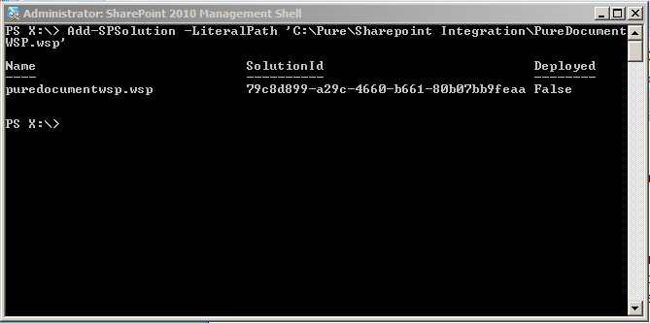

- Deploy the PureDocument feature on the server using Solution Management on the Central Administration site.
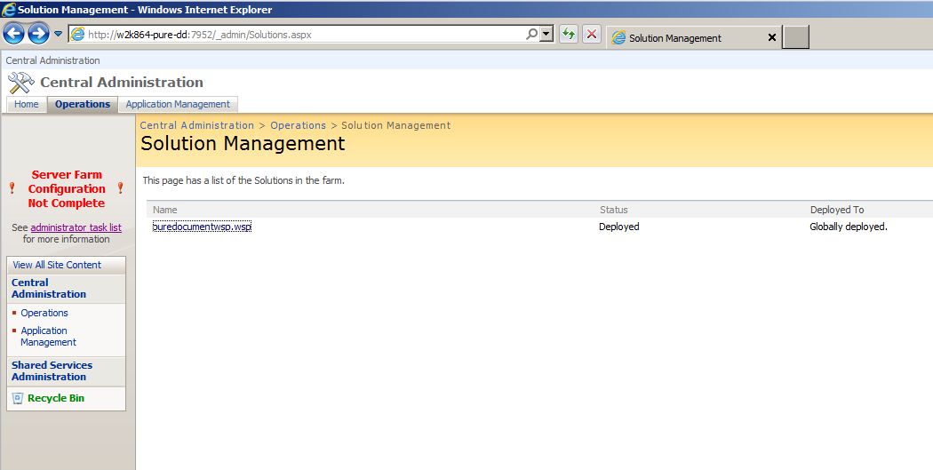
- Activate the PureDocument feature on the Document Site.
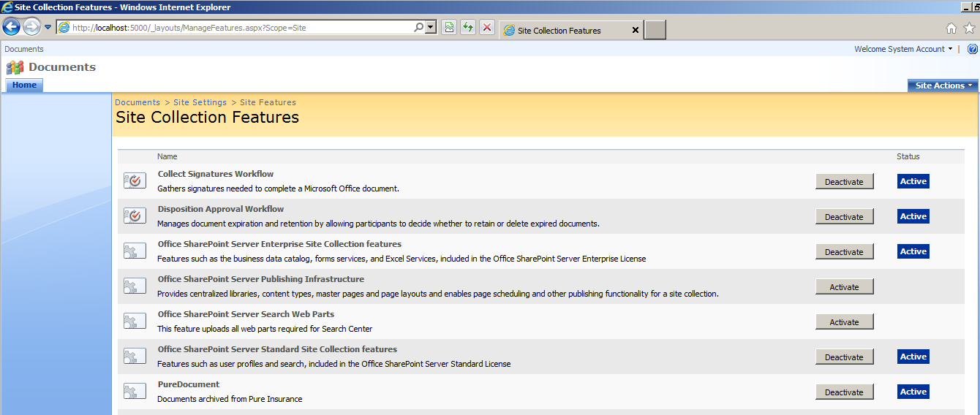

- You need to enable the Content Type management.
  - Document > Shared Documents > Document Library Settings
    - Customize Shared Documents
      - Advanced Settings - Allow Management of the Content Types
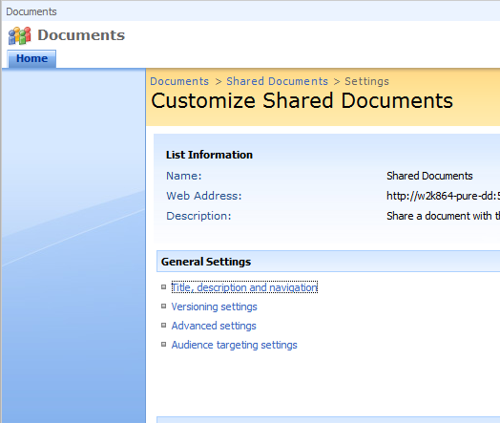

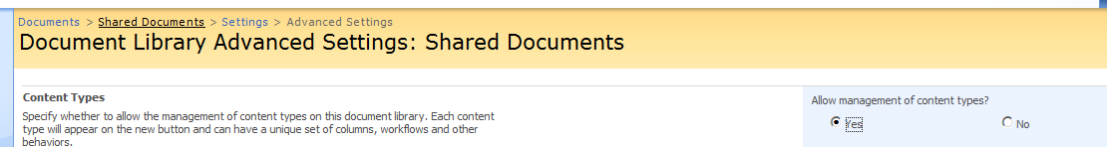

- Add the PureDocument Content type and make it the default for Documents.
  - Documents > Shared Documents > Document Library Settings
    - Add Content Types - add the PureDocument type to the List
    - Change the order for the PureDocument type to 1.
- The Content Types will be left looking like this.
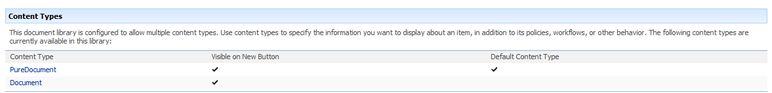
- Finally, the System Options in the Pure Back Office need to be set to enabled Sharepoint integration. The Document Library needs to be the name of the Library and not the URL.
